**Z ITA144-ETHICAL HACKING**

**LAB MANUAL**

**Exercise No 1:** **Nmap Scan**

**Aim:**

To install and perform Nmap scan (note :- you may use ip address or website name)

**Procedure:**

Step 1: Open Nmap from Kali Linux (Goto Applications->select Information Gathering->select

Nmap)

Step 2: Perform different types of scan

(Tcp, Udp, Ack, Syn, Fin, Null, Xmas, Rpc, Idle)- scan types

**Scanning Techniques**

|  |  |  |
| --- | --- | --- |
| **Flag** | **Use** | **Example** |
| **-sS** | **TCP syn port scan** | **nmap -sS 192.168.1.1** |
| **-sT** | **TCP connect port scan** | **nmap -sT 192.168.1.1** |
| **–sU** | **UDP port scan** | **nmap –sU 192.168.1.1** |
| **–sA** | **TCP ack port scan** | **nmap –sA 192.168.1.1** |

Step 3:-

To perform host discovery

|  |  |  |
| --- | --- | --- |
| -Pn | only port scan | nmap -Pn192.168.1.1 |
| -sn | only host discover | nmap -sn192.168.1.1 |
| -PR | arp discovery on a local network | nmap -PR192.168.1.1 |
| -n | disable DNS resolution | nmap -n 192.168.1.1 |

Step4:-

**Port Specification**

|  |  |  |
| --- | --- | --- |
| **Flag** | **Use** | **Example** |
| **-p** | **specify a port or port range** | **nmap -p 1-30 192.168.1.1** |
| **-p-** | **scan all ports** | **nmap -p- 192.168.1.1** |
| **F** | **fast port scan** | **nmap -F 192.168.1.1** |

Step 5:-

***Service Version and OS Detection***

|  |  |  |
| --- | --- | --- |
| Flag | Use | Example |
| -sV | detect the version of services running | nmap -sV 192.168.1.1 |
| -A | aggressive scan | nmap -A 192.168.1.1 |
| -O | detect operating system of the target | nmap -O 192.168.1.1 |

Step 6:-

Timing and Performance

|  |  |  |
| --- | --- | --- |
| Flag | Use | Example |
| -T0 | paranoid IDS evasion | nmap -T0 192.168.1.1 |
| -T1 | sneaky IDS evasion | nmap -T1 192.168.1.1 |
| -T2 | polite IDS evasion | nmap -T2 192.168.1.1 |
| -T3 | normal IDS evasion | nmap -T3 192.168.1.1 |
| -T4 | aggressive speed scan | nmap -T4 192.168.1.1 |
| -T5 | insane speed scan | nmap -T5 192.168.1.1 |

Output:

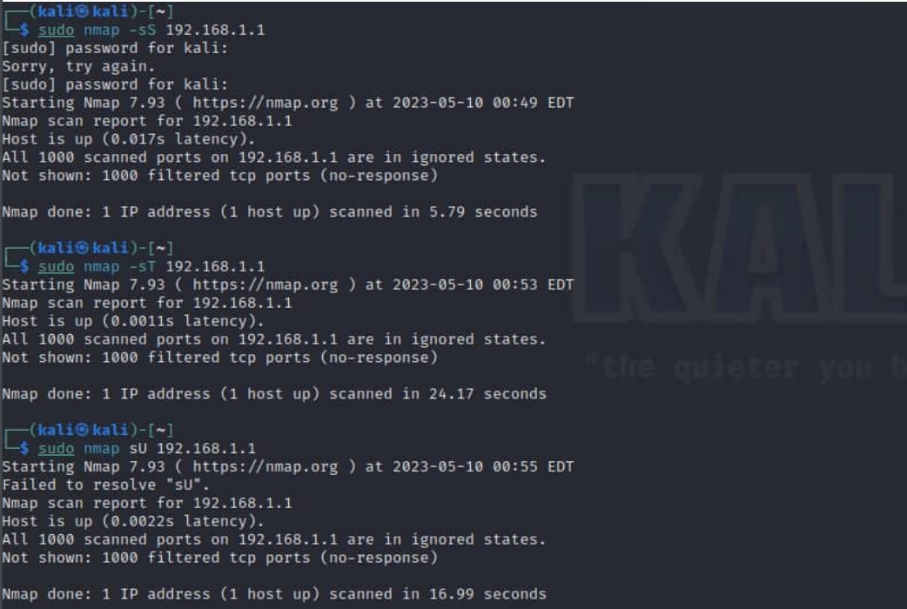

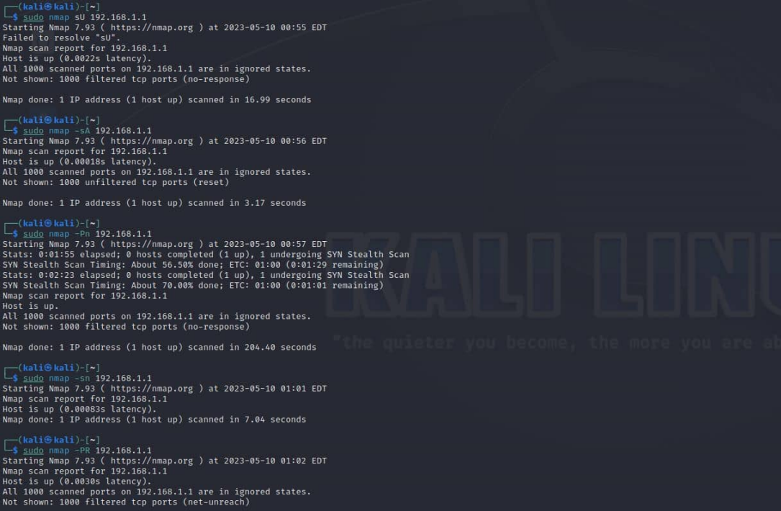

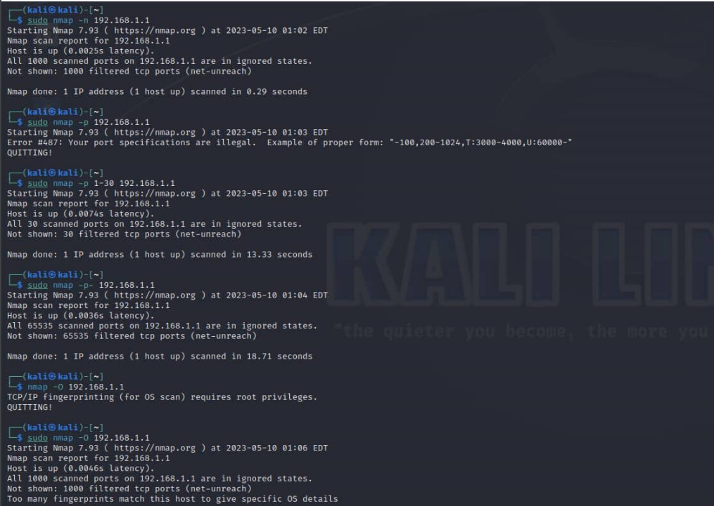

**Result:** Performing nmap scan using ip address is successful.

**EX.NO: 2**

**BATCH FILE EXECUTION**

**AIM:** To create a Windows batch file.

**PROCEDURE:**

Step 1 : Open a text file, such as a Notepad or WordPad document.

Step 2 : Add your commands, starting with @echo [off], followed by, each in a new line, title [title of your batch script], echo [first line], and pause

Step 3 : Save your file with the file extension BAT, for example, test.bat.

Step 4 : To run your batch file, double-click the BAT file you just created.

Step 5 : To edit your batch file, right-click the BAT file and select Edit. And here's the corresponding command window for the example above: 1.Create a New Text Document A batch file simplifies repeatable computer tasks using the Windows command prompt. Below is an example of a batch file responsible for displaying some text in your command prompt. Create a new BAT file by right-clicking an empty space within a directory and selecting New, then Text Document. 1.CODE Double-click this New Text Document to open your default text editor. Copy and paste the following code into your text entry. >> @echo off >> echo hello >> Pause >> echo This is new >> echo this is second one >> pause 1. TO SAVE a BAT File The above script echoes back the text "Welcome to batch scripting!" Save your file by heading to File > Save As, and then name your file what you'd like. End your file name with the added BAT extension, for example test.bat, and click OK. This will finalize the batch process. Now, double-click on your newly created batch file to activate it. 2.To RUN as BAT File Once you'd saved your file, all you need to do is double-click your BAT file. Instantly, your web pages will open. If you'd like, you can place this file on your desktop. This will allow you to access all of your favorite websites at once.

**OUTPUT-**

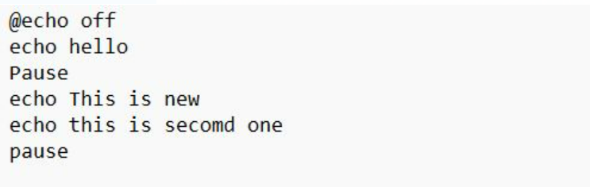

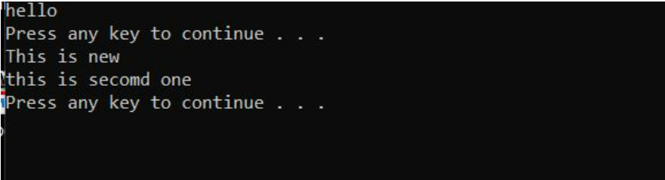

**RESULT-**

Creating a windows batch file is successful.

**Exercise No 3:** **Vulnerability Access Scan Using Nessus**

**Aim :** To Download and install Nessus tool and perform a Vulnerability Access scan in kali Linux Operating systems.

**PROCEDURE-**

Step 1:- <https://www.tenable.com/downloads/nessus?loginAttempted=true>

Step 2: Choose your OS and download , instalL

Step 3: Once installation is completed it will open in default browseR

Step 5:- (click on the proceed to local host)

Step 6:- Please choose the Nessus Expert.

Step 7: Click on continue

Step 8:- Register with your organizational email id

Step 9:- please note down the activation.

Step 10:- set up your username & password

Step 11:-Type username and passworD

Step 12:- Please wait until download is completed

Step 13: Select My Scans

**OUTPUT-**

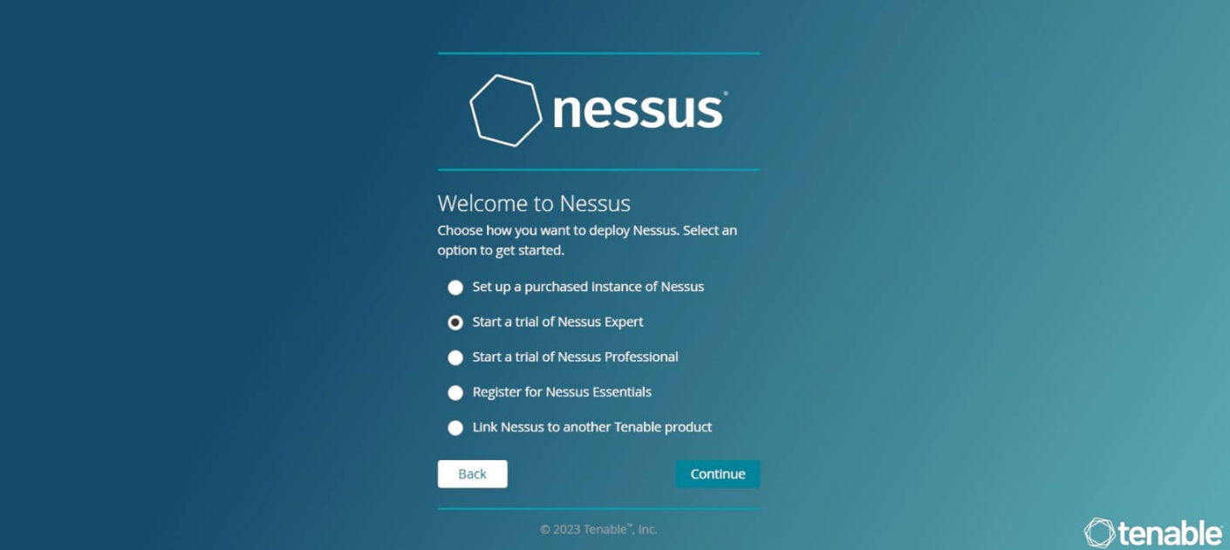

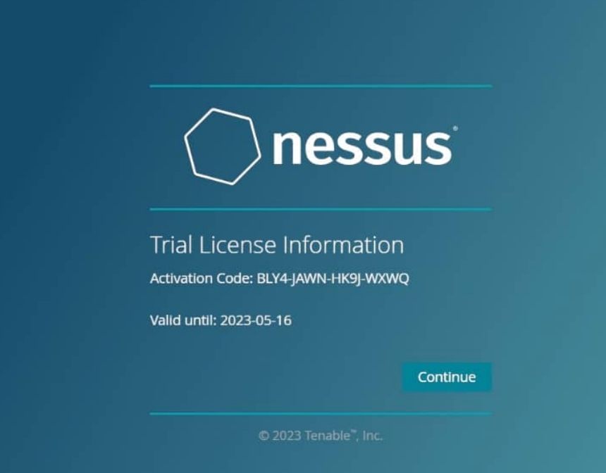

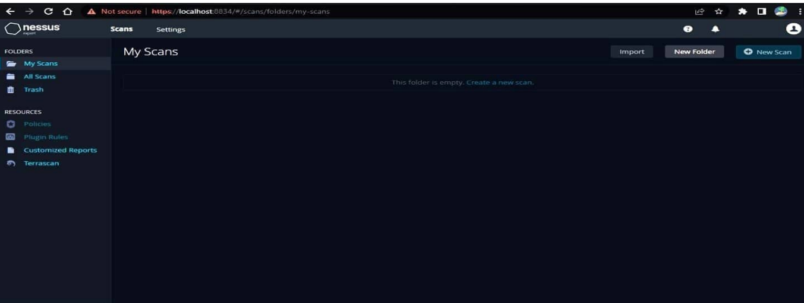

**RESULT-**

Using Nessus tool and performing Vulnerability Access scan in kali Linux Operating systems.

**Exercise No 4:** **Website Penetration Testing**

**Aim:** To demonstrate Website Penetration Testing offered by Kali Linux.

**Procedure:**

Step 1 − To open Vega go to Applications → 03-Web Application Analysis → Vega

Step 2 − If you don’t see an application in the path, type the following command.

Step 3 − To start a scan, click “+” sign.

Step 4 − Enter the webpage URL that will be scanned. In this case, it is metasploitable machine → click “ Next”.

Step 5 − Check all the boxes of the modules you want to be controlled. Then, click “Next”.

Step 6 − Click “Next” again in the following screenshot.

Step 7 − Click “Finish”.

Step 8 − If the following table pops up, click “Yes”.

The scan will continue as shown in the following screenshot.

Step 9 − After the scan is completed, on the left down panel you can see all the findings, that are categorized according to the severity. If you click it, you will see all the details of the vulnerabilities on the right panel such as “Request”, ”Discussion”, ”Impact”, and ”Remediation”.

**OUTPUT-**

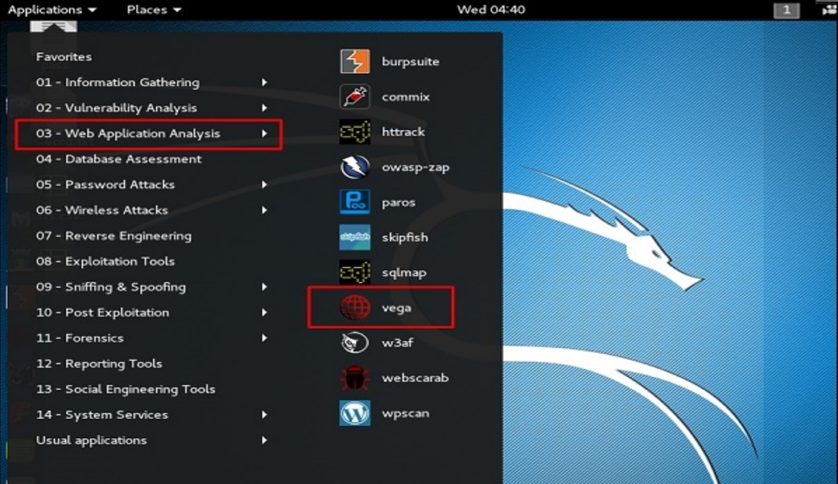

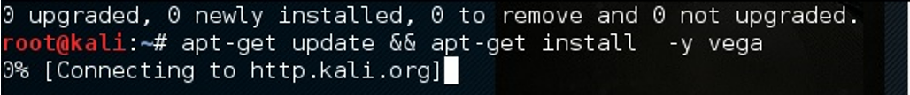

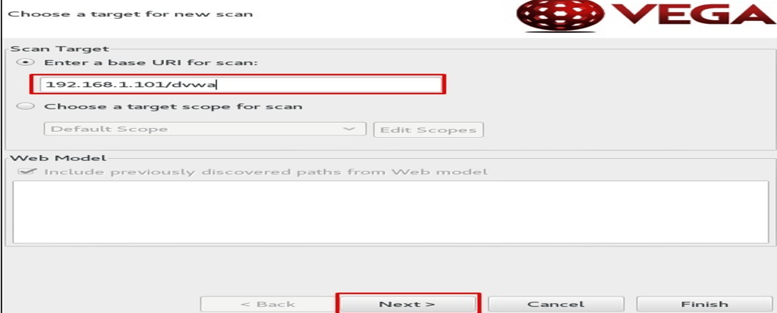

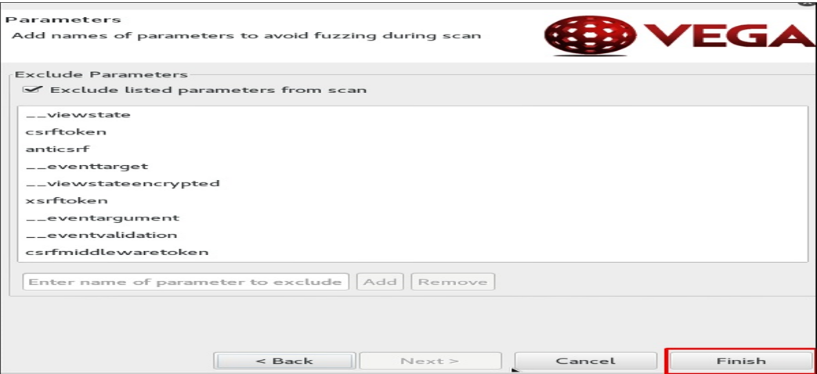

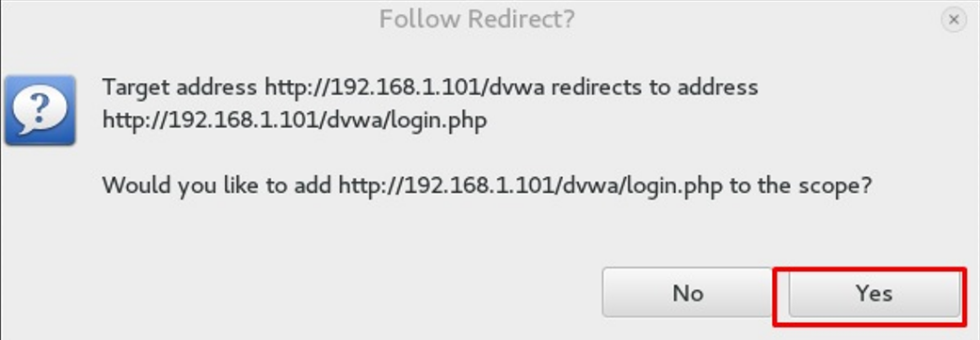

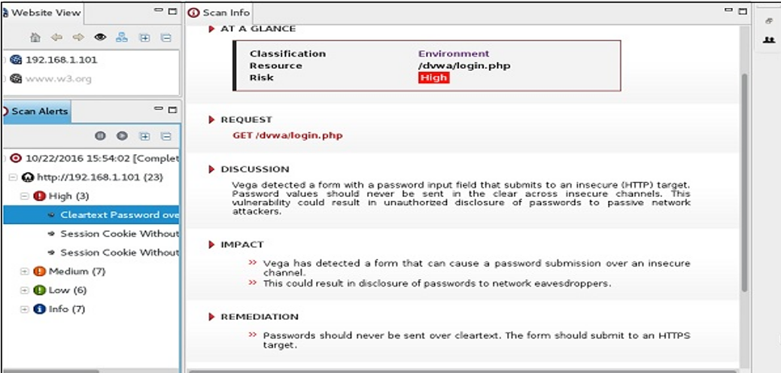

**RESULT-**

Demonstrating Website Penetration Testing offered by Kali Linux is successful.

Exercise No 5: Information gathering using theHarvester

Aim: To demonstrate information gathering using theHarvester

Procedure:

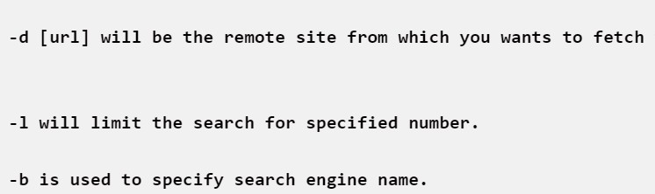STEP 1: Open Terminal in the kali linux

STEP 2: Run the following command

Command: theHarvester -d [www.zoho.com](http://www.zoho.com/) -l

Step 4: run this command “**theHarvester -d** [**www.zoho.com**](http://www.zoho.com/) **-l 300 -b all -f test” and** hit enter

to export the result as html file and xml file.

Step 5: now close the terminal and navigate the home folder and search for test file .

**OUTPUT-**

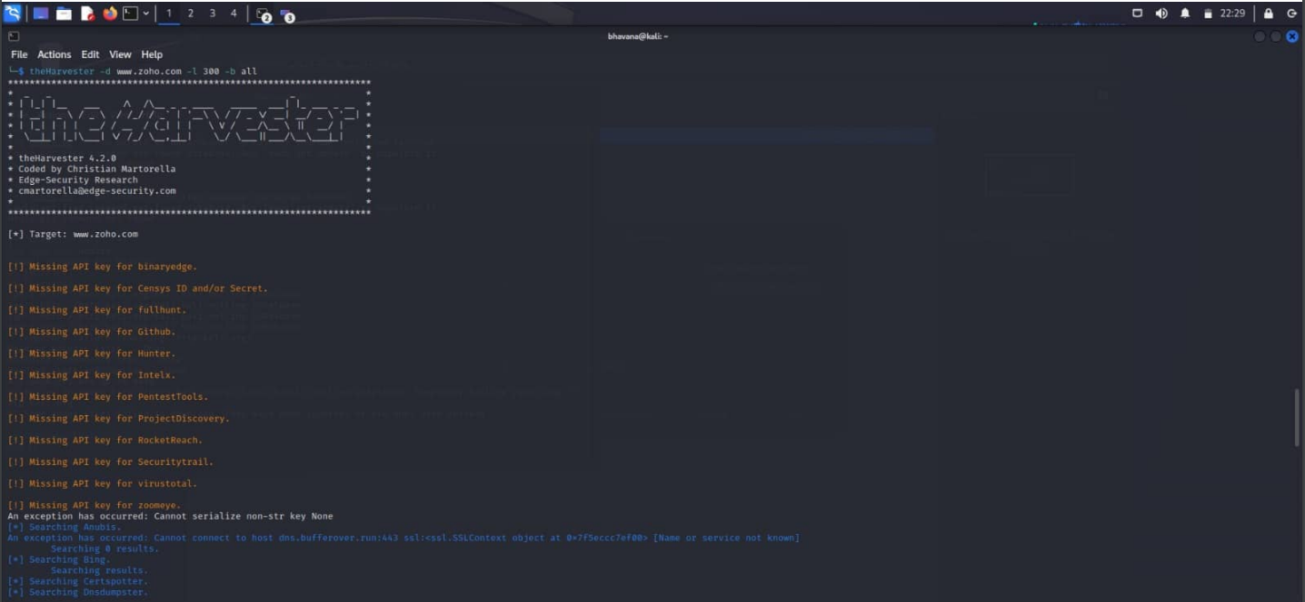

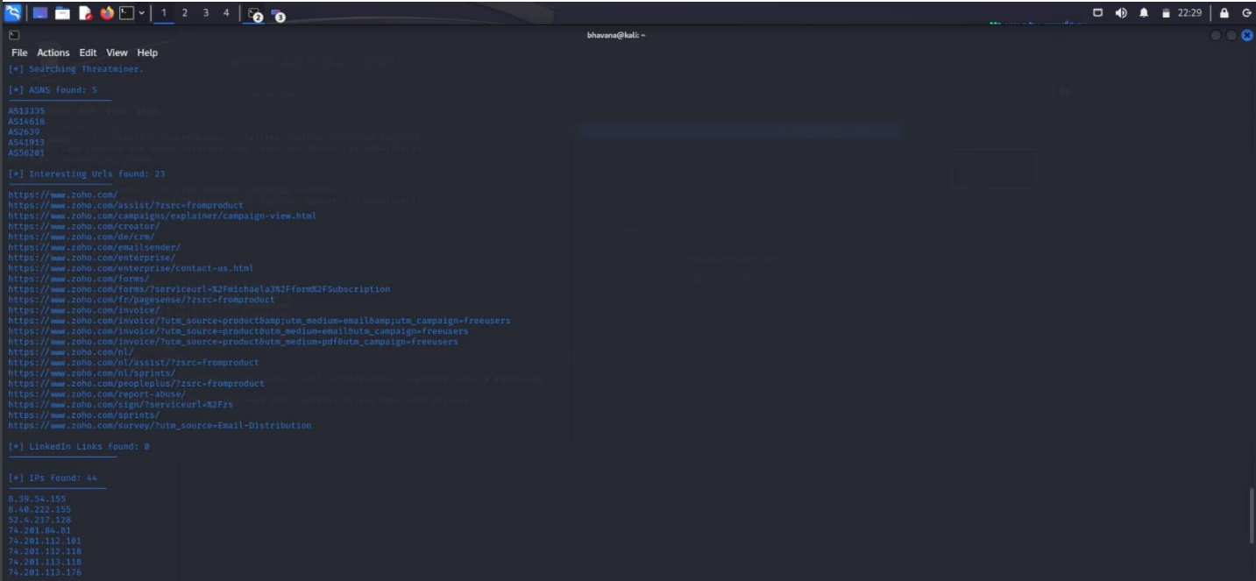

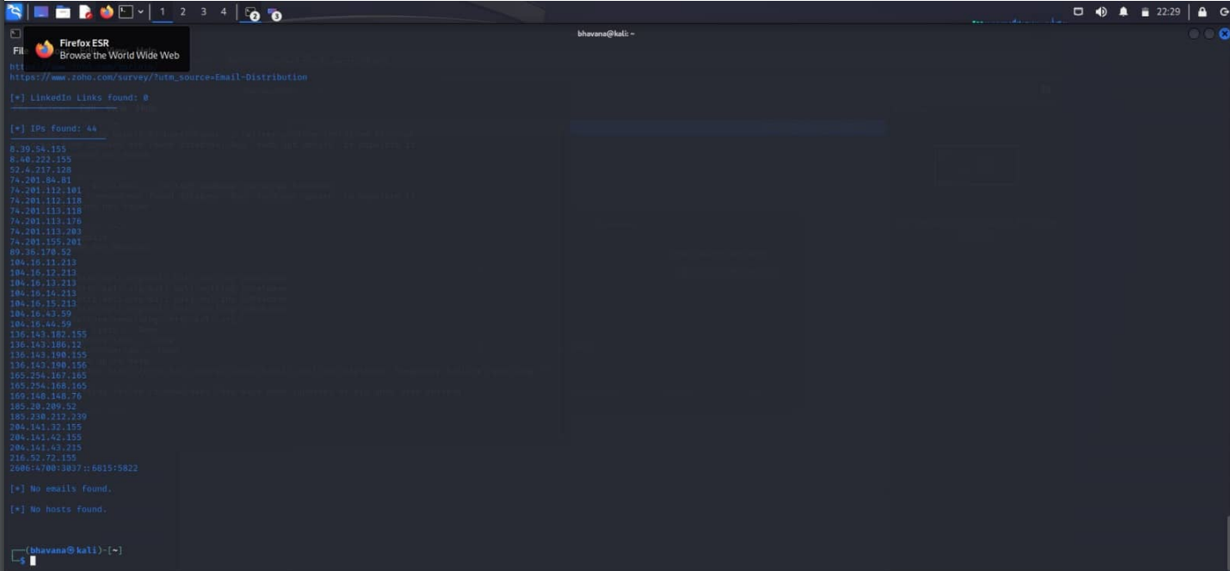

**RESULT-**

Demonstrating information gathering using theHarvester is successful.

**Exercise No 6 - Open Source Intelligence Gathering Using OSRFramework**

**Aim:** To Checks for the Existence of a Profile for given user details in different platforms

**Procedure:**

Step 1: Log into kali linux machine

Step 2: Launch a command line terminal by clicking on terminal icon from taskbar

Step 3: Usufy.py checks for the existence of a profile for given user details in different

platforms

**Command:**

## Usufy.py -n <Target username or profile name> -p twitter facebook youtube

If any error occurs Try this command: **Sudo apt-getupdate**

## The usufy.py will search the user details in the mentioned platform and will provide you with the existence of the user

**OUTPUT-**

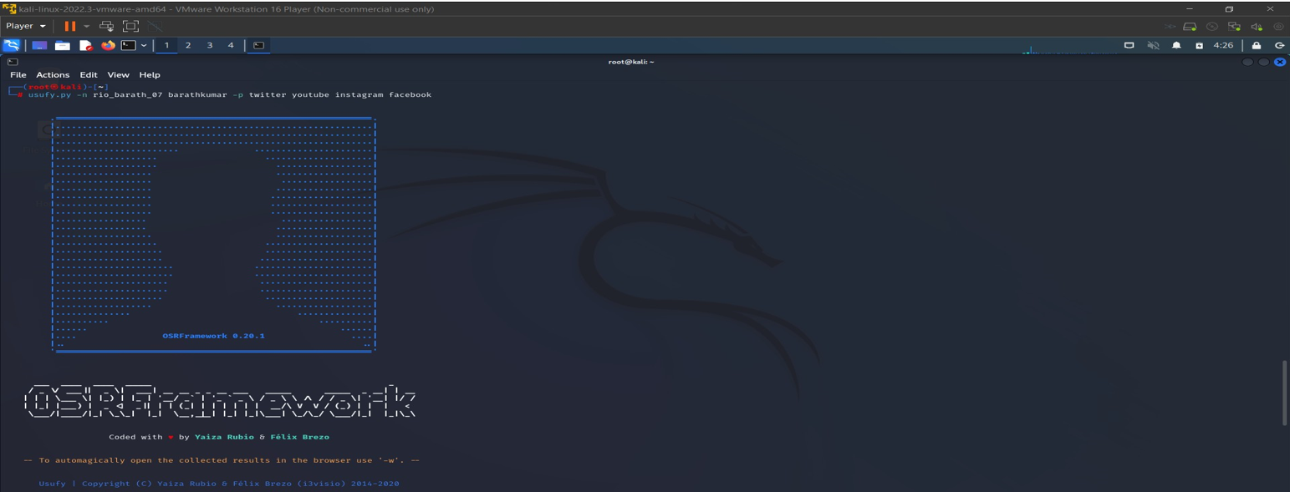

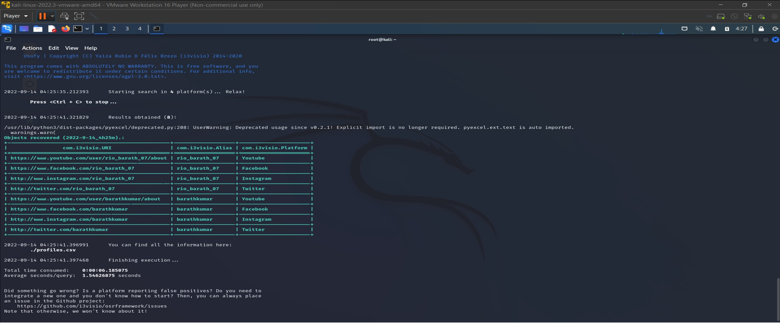

**RESULT-**

Checking for the Existence of a Profile for given user details in different platforms is sucessful.

**Exercise NO 7: Use Google and Whois for Reconnaisasance.**

Aim: To find out the Whois, DNS Records and Diagonstics for particular website by using Whois search.

Procedure:

Step1: Open the WHO.is website



Step 2: Enter the website name in search bar and hit the “Enter button”.

Step 3: Show you information about [www.saveetha.com](http://www.saveetha.com/)

**OUTPUT-**

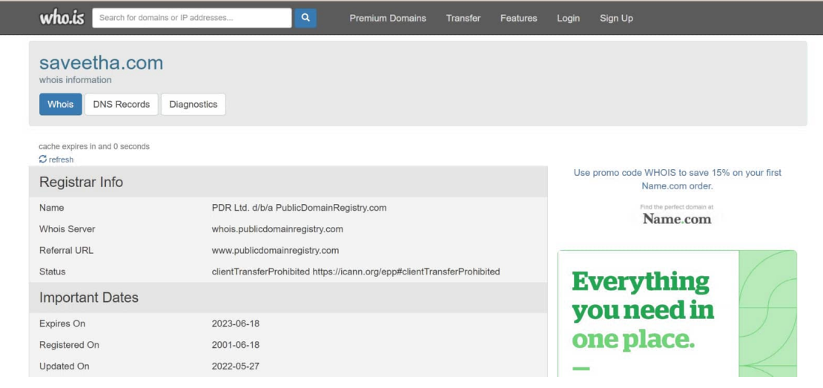

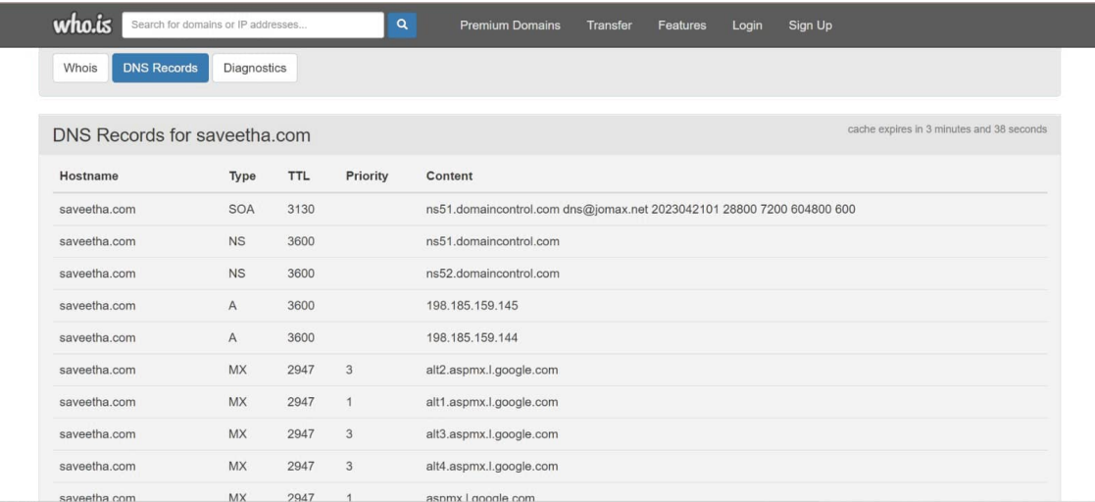

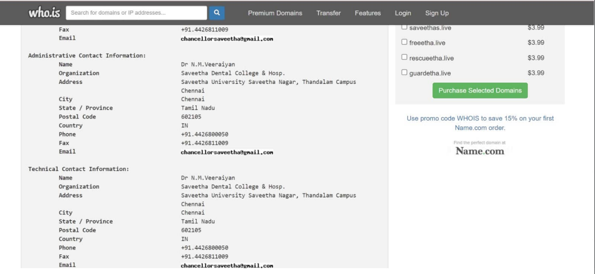

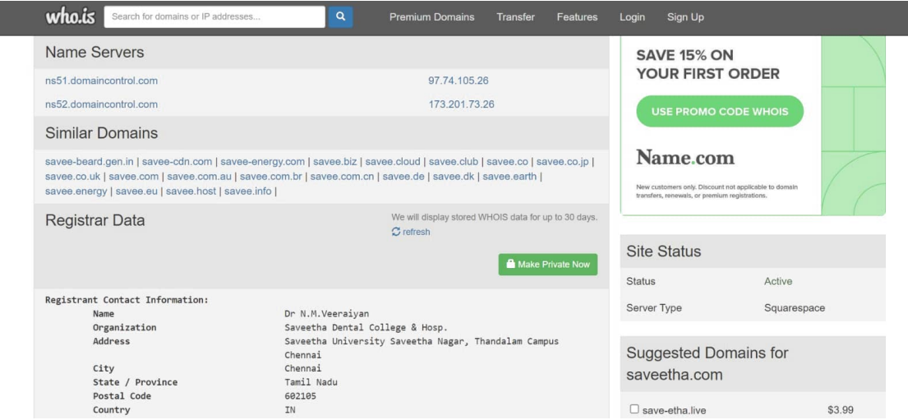

RESULT-: To find out the Whois, DNS Records and Diagonstics for particular website by using Whois search is successful.

**Exercise No 8: TraceRoute, ping, ifconfig, ipconfig, netstat**

**Aim:** Using TraceRoute, ping, ifconfig(LINUX), ipconfig(WINDOWS), and netstat

Command.

Procedure:

Step 1: open windows command prompt and Type tracert command and type tracert

[www.saveetha.com](http://www.saveetha.com/) -> “Enter”

Step 2: Type ping command and type IP Address press “Enter”

Step 3: Type ifconfig command

Step 4: Type netstat command

**OUTPUT-**

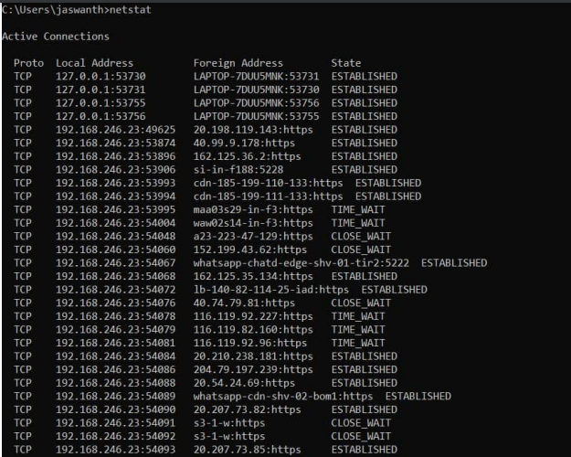

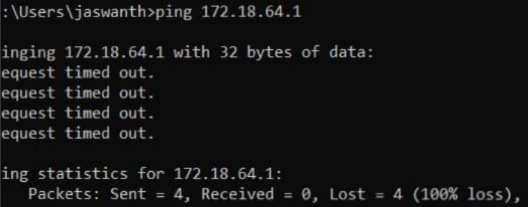

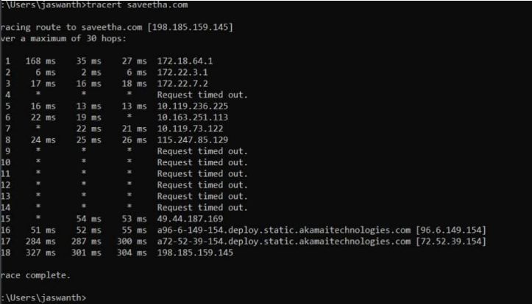

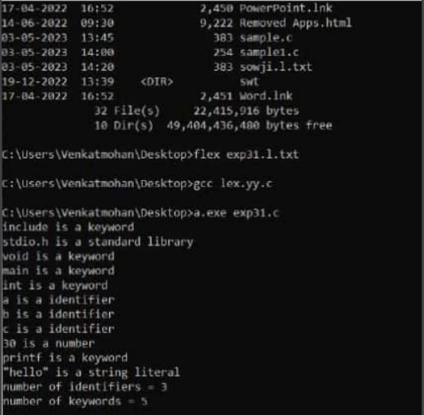

**RESULT-**

Using TraceRoute, ping, ifconfig(LINUX), ipconfig(WINDOWS), and netstat

Command is successful.

Exercise No 9:VULNERABILITY ANALYSIS - CGI Scanning with Nikto

Aim:To perform vulnerability Analysis using CGI Scanning with Nikto

Procedure:

Step 1: open a terminal window and type nikto –H and press enter

Step 2: Type nikto –h <website> Tuning x and press enter

Step 3: Nikto starts web server scanning with all tuning options enabled.

Step4:In the terminal window type “nikto –h <website>-Cgidirs all”and hit enter

Step 5. Nikto will scan the webserver as it looks vulnerable CGI directories. It scans the webserver and list out the directories

**OUTPUT-**

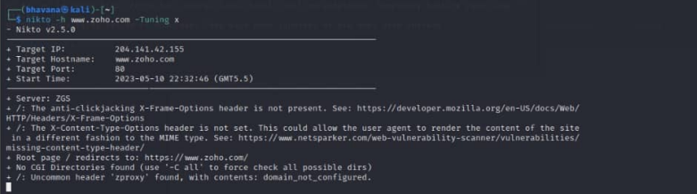

**RESULT-**

To perform vulnerability Analysis using CGI Scanning with Nikto is successful.